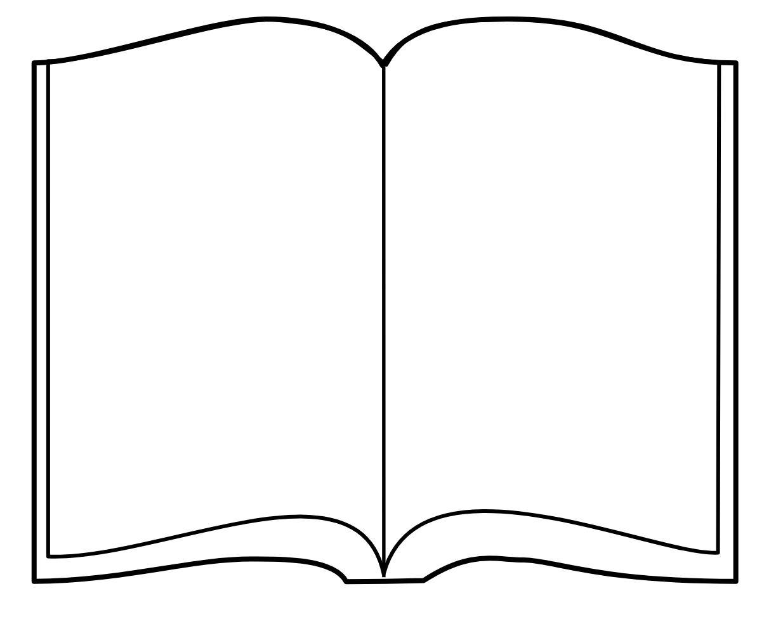  Dear family,  This is my library book from school.  Please help me read my library book, and return it to my backpack every night.  We will have fun reading together!  Love, | Dear family,  This is my library book from school.  Please help me read my library book, and return it to my backpack every night.  We will have fun reading together!  Love, | Dear family,  This is my library book from school.  Please help me read my library book, and return it to my backpack every night.  We will have fun reading together!  Love,

