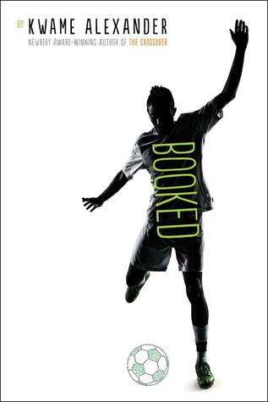
Booked by
Kwame Alexander
Soccer, family, love, and friendship take center stage as twelve-year-old Nick learns the power of words. He has a lot going on: he wrestles with problems at home, stands up to a bully, and tries to impress the girl of his dreams. Helping him along are his best friend and sometimes teammate Coby, and The Mac, a rapping librarian who gives Nick inspiring books to read.
This electric and heartfelt novel-in-verse by poet Kwame Alexander bends and breaks as it captures all the thrills and setbacks, action and emotion of a World Cup match.

Like lightning you strike
fast and free
legs zoom down field
eyes fixed on the checkered ball
on the goal
ten yards to go
can’t nobody stop you
can’t nobody cop you

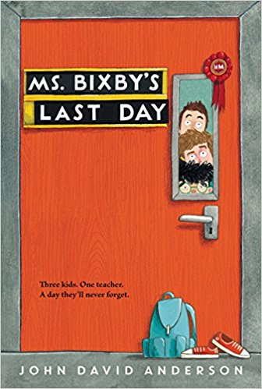
Ms. Bixby’s Last Day
by John David Anderson

Everyone knows there are different kinds of teachers. The boring ones, the mean ones, the ones who try too hard, the ones who stopped trying long ago. The ones you'll never remember, and the ones you want to forget. Ms. Bixby is none of these. She's the sort of teacher who makes you feel like school is somehow worthwhile. Who recognizes something in you that sometimes you don't even see in yourself. Who you never want to disappoint. What Ms. Bixby is, is one-of-a-kind.
Topher, Brand, and Steve know this better than anyone. And so when Ms. Bixby unexpectedly announces that she won't be able to finish the school year, they come up with a risky plan, more of a quest, really, to give Ms. Bixby the last day she deserves. Through the three very different stories they tell, we begin to understand what Ms. Bixby means to each of them—and what the three of them mean to each other.

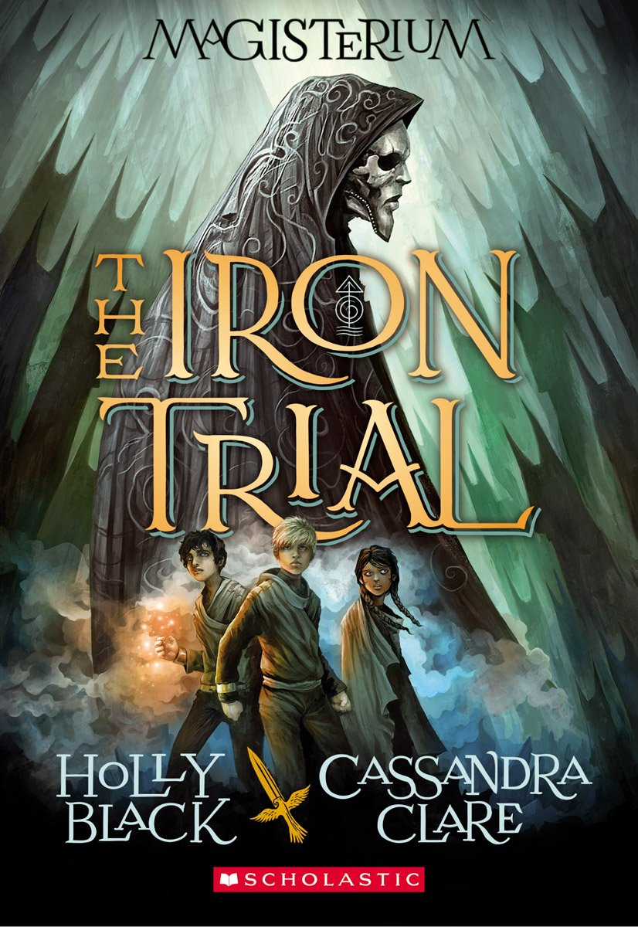
The Iron Trial
by Holly Black
and Clare Cassandra
Most kids would do anything to pass the Iron Trial. Not Callum Hunt. He wants to fail.
All his life, Call has been warned by his father to stay away from magic. If he succeeds at the Iron Trial and is admitted into the Magisterium, he is sure it can only mean bad things for him.
So he tries his best to do his worst -- and fails at failing.
Now the Magisterium awaits him. It's a place that's both sensational and sinister, with dark ties to his past and a twisty path to his future.
The Iron Trial is just the beginning, for the biggest test is still to come.
From the remarkable imaginations of bestselling authors Holly Black and Cassandra Clare comes a heart-stopping, mind-blowing, pulse-pounding plunge into the magical unknown.
Unbound
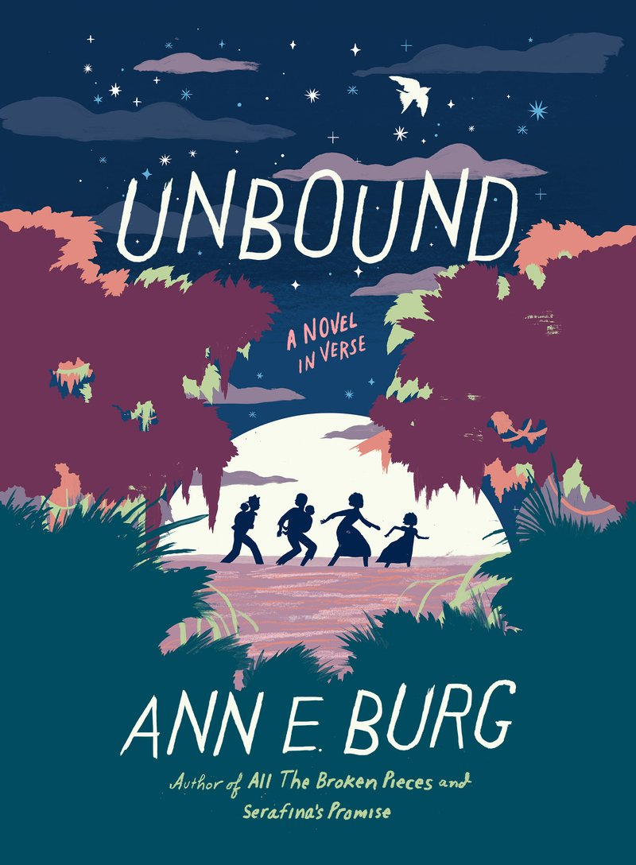
by Ann Burg

The day Grace is called from the slave cabins to work in the Big House, Mama makes her promise to keep her eyes down. Uncle Jim warns her to keep her thoughts tucked private in her mind or they could bring a whole lot of trouble and pain.
But the more Grace sees of the heartless Master and hateful Missus, the more a rightiness voice clamors in her head-asking how come white folks can own other people, sell them on the auction block, and separate families forever. When that voice escapes without warning, it sets off a terrible chain of events that prove Uncle Jim's words true. Suddenly, Grace and her family must flee deep into the woods, where they brave deadly animals, slave patrollers, and the uncertainty of ever finding freedom.
With candor and compassion, Ann E. Burg sheds light on a startling chapter of American history--the remarkable story of runaways who sought sanctuary in the Great Dismal Swamp--and creates a powerful testament to the right of every human to be free.
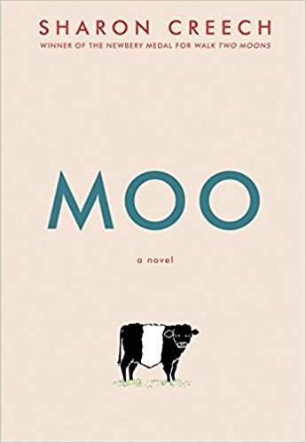
Moo
by Sharon Creech
Fans of Newbery Medal winner Sharon Creech’s Love That Dog and Hate That Cat will love her newest tween novel, Moo. Following one family’s momentous move from the city to rural Maine, an unexpected bond develops between twelve-year-old Reena and one very ornery cow.
When Reena, her little brother, Luke, and their parents first move to Maine, Reena doesn’t know what to expect. She’s ready for beaches, blueberries, and all the lobster she can eat. Instead, her parents “volunteer” Reena and Luke to work for an eccentric neighbor named Mrs. Falala, who has a pig named Paulie, a cat named China, a snake named Edna—and that stubborn cow, Zora.
This heartwarming story, told in a blend of poetry and prose, reveals the bonds that emerge when we let others into our lives.

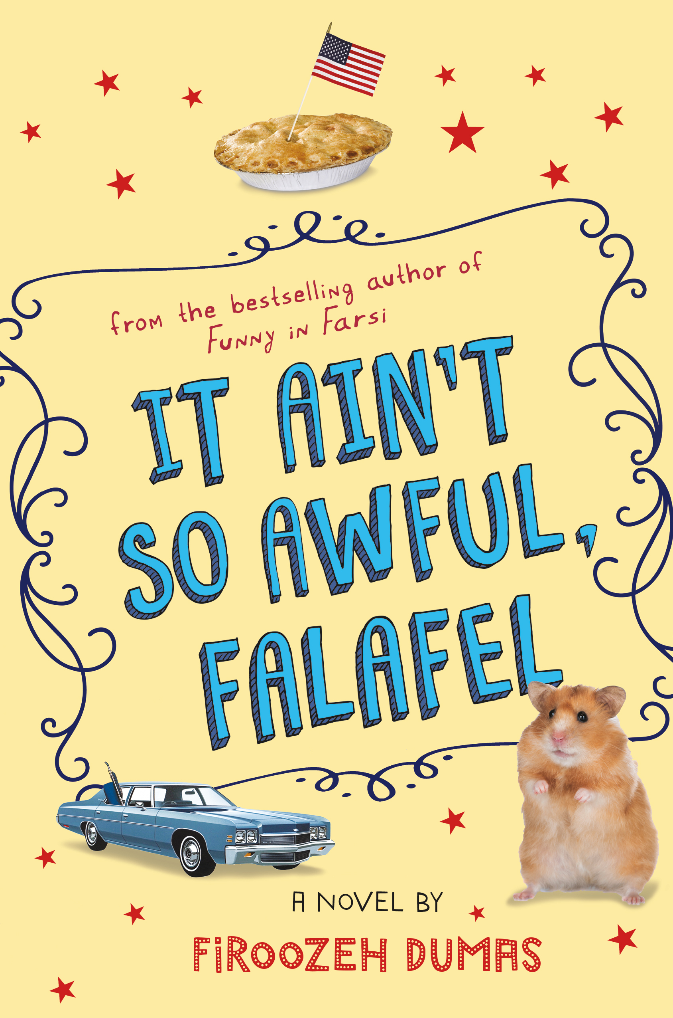
It Ain’t So Awful, Falafel
By Firoozeh Dumas

Zomorod Yousefzadeh is the new kid on the block… for the fourth time. California’s Newport Beach is her family’s latest perch, and she’s determined to shuck her brainy loner persona and start afresh with a new Brady Bunch name—Cindy.
It’s the late 1970s, and fitting in becomes more difficult as Iran makes U.S. headlines with protests, revolution, and finally the taking of American hostages. Even puka shell necklaces, pool parties, and flying fish can't distract Cindy from the anti-Iran sentiments that creep way too close to home. A poignant yet lighthearted middle grade debut from the author of the best-selling Funny in Farsi.

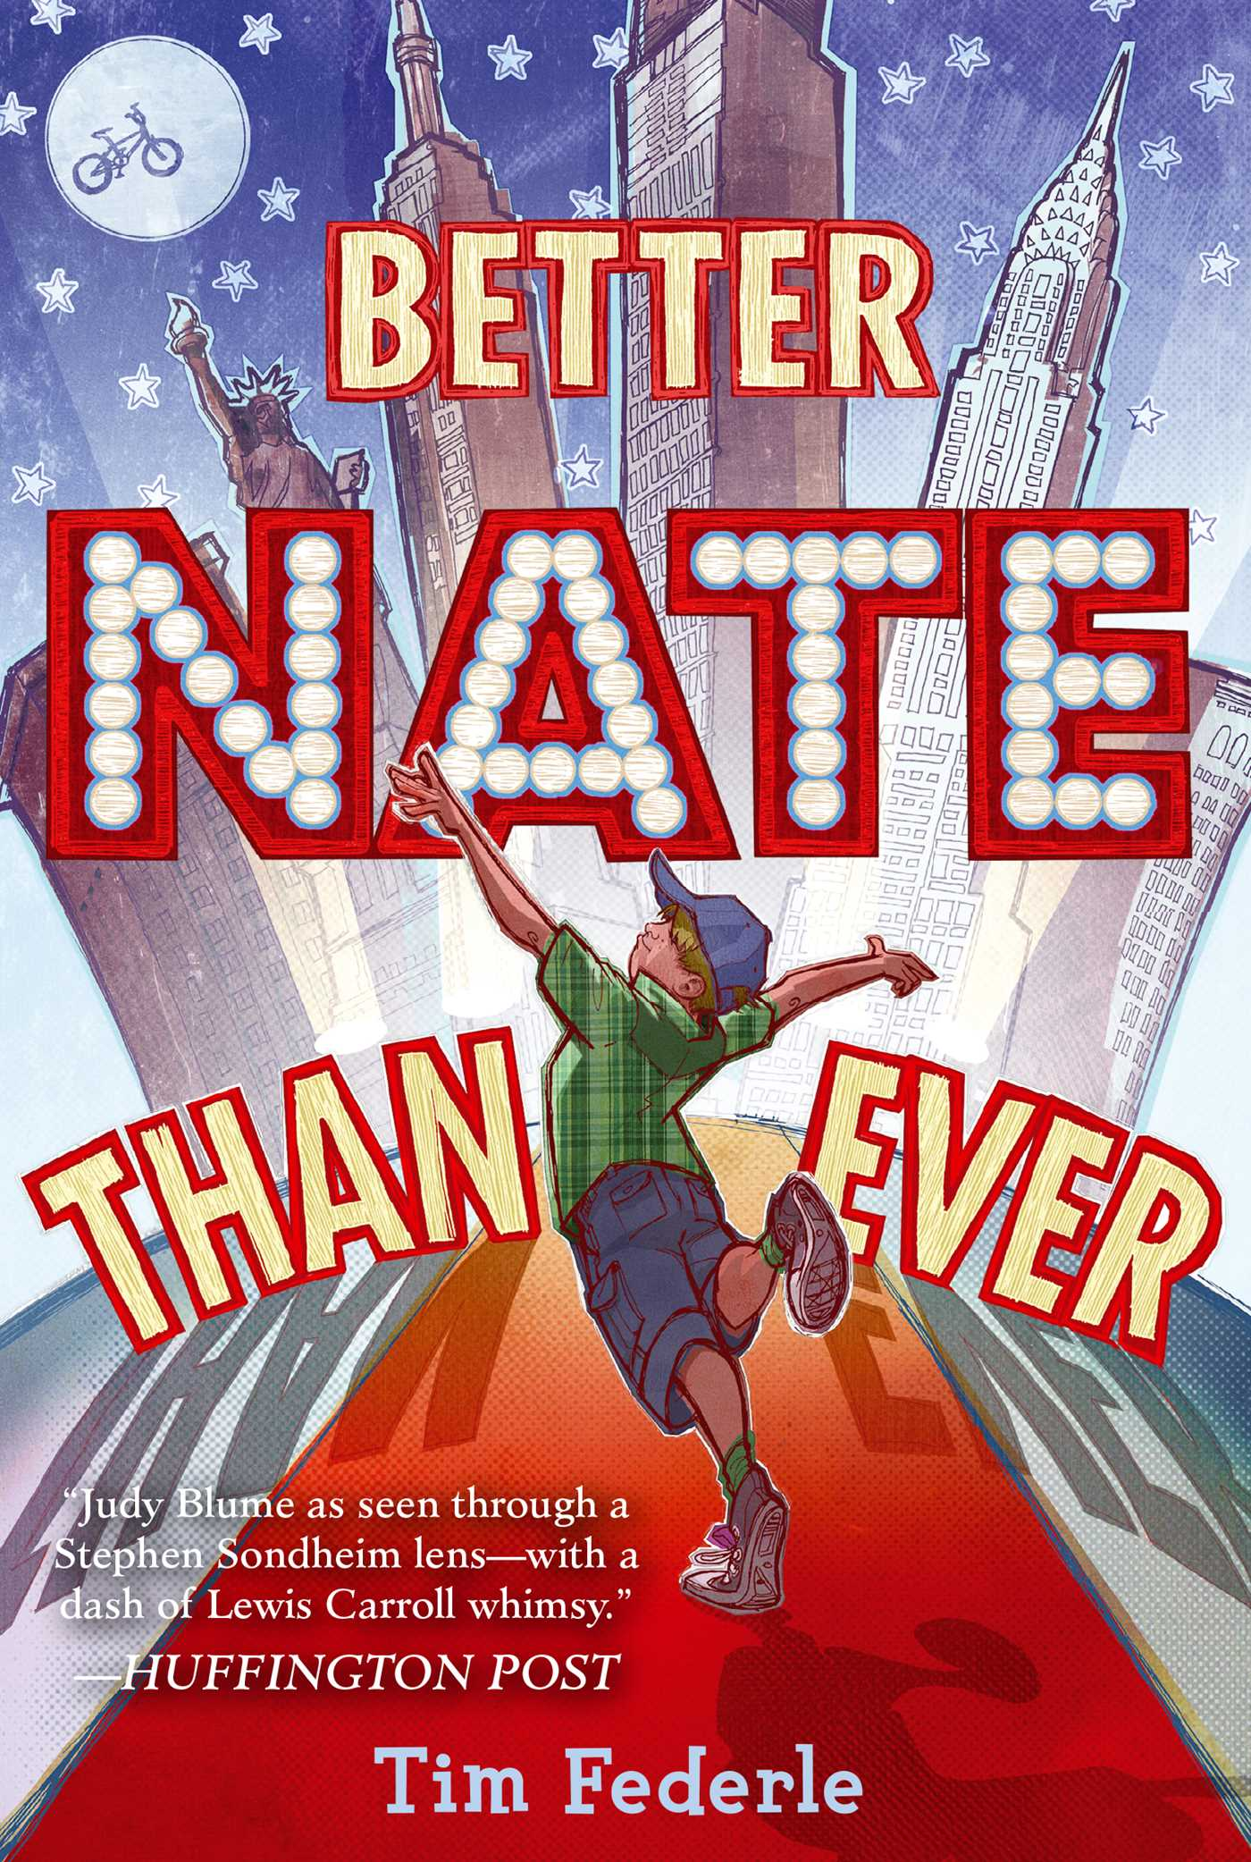
Better Nate Than Ever
by Tim Federle

Nate Foster has big dreams. His whole life, he’s wanted to star in a Broadway show. (Heck, he’d settle for seeing a Broadway show.) But how is Nate supposed to make his dreams come true when he’s stuck in Jankburg, Pennsylvania, where no one (except his best pal Libby) appreciates a good show tune? With Libby’s help, Nate plans a daring overnight escape to New York. There’s an open casting call for E.T.: The Musical, and Nate knows this could be the difference between small-town blues and big-time stardom.
Tim Federle’s “hilarious and heartwarming debut novel” (Publishers Weekly) is full of broken curfews, second chances, and the adventure of growing up—because sometimes you have to get four hundred miles from your backyard to finally feel at home.

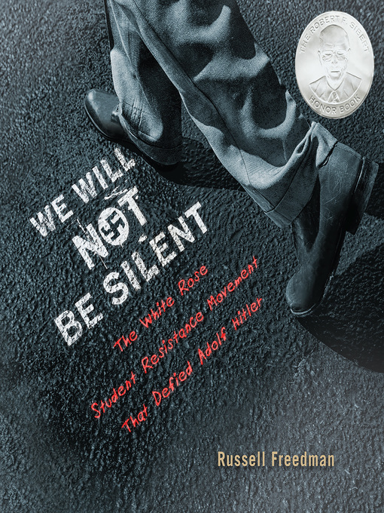
We Will Not Be Silent
by Russell Freedman

Hans Scholl, a free-spirited teen who became disillusioned by the enforced conformity of his Hitler Youth group, joined a banned rival group that discussed forbidden books, and there were no uniforms or marching. Younger sister Sophie got in trouble for reading a book by a Jewish German poet and questioning the pervasive anti-Semitism of her society.

While attending school in Munich, the siblings became active in a group of anti-Hitler pamphleteers. The story has its share of dark turns, including arrests, lengthy detentions, and the eventual trial and execution by guillotine of Hans and Sophie. But Freedman treats these aspects gracefully, and the overarching message is one of defiant resistance in the face of overwhelming evil. "You will go down in history," their father, an outspoken pacifist, told them after their conviction. "There is such a thing as justice despite this. I am proud of both of you."

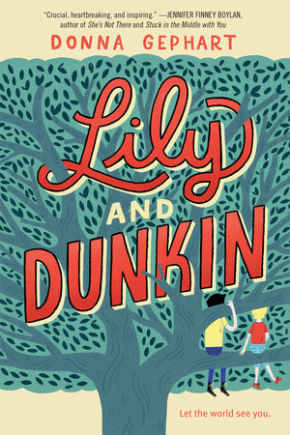
Lily and Dunkin
by Donna Gephart

Lily Jo McGrother, born Timothy McGrother, is a girl. But being a girl is not so easy when you look like a boy. Especially when you’re in the eighth grade.
Dunkin Dorfman, birth name Norbert Dorfman, is dealing with bipolar disorder and has just moved from the New Jersey town he’s called home for the past thirteen years. This would be hard enough, but the fact that he is also hiding from a painful secret makes it even worse.
One summer morning, Lily Jo McGrother meets Dunkin Dorfman, and their lives forever change.

"A thoughtfully and sensitively written work of character-driven fiction that dramatically addresses two important subjects that deserve more widespread attention." – Booklist

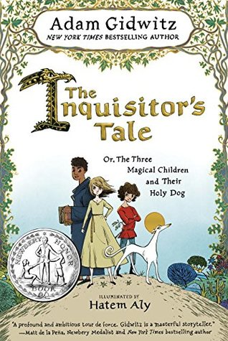
The Inquisitor’s Tale
By Adam Gidwitz

On a dark night, travelers from across France cross paths at an inn and begin to tell stories of three children. Adventures take them on a chase through France: they are taken captive by knights, sit alongside a king, and save the land from a dragon. On the run to escape prejudice and persecution and save precious and holy texts from being burned, their quest drives them forward to a final showdown at Mont Saint-Michel, where all will come to question if these children can perform the miracles of saints.
Beloved bestselling author Adam Gidwitz makes his long awaited return with his first new world since his hilarious and critically acclaimed Grimm series. Featuring manuscript illuminations throughout by illustrator Hatem Aly and filled with Adam’s trademark style and humor, The Inquisitor's Tale is bold storytelling that’s richly researched and adventure-packed.

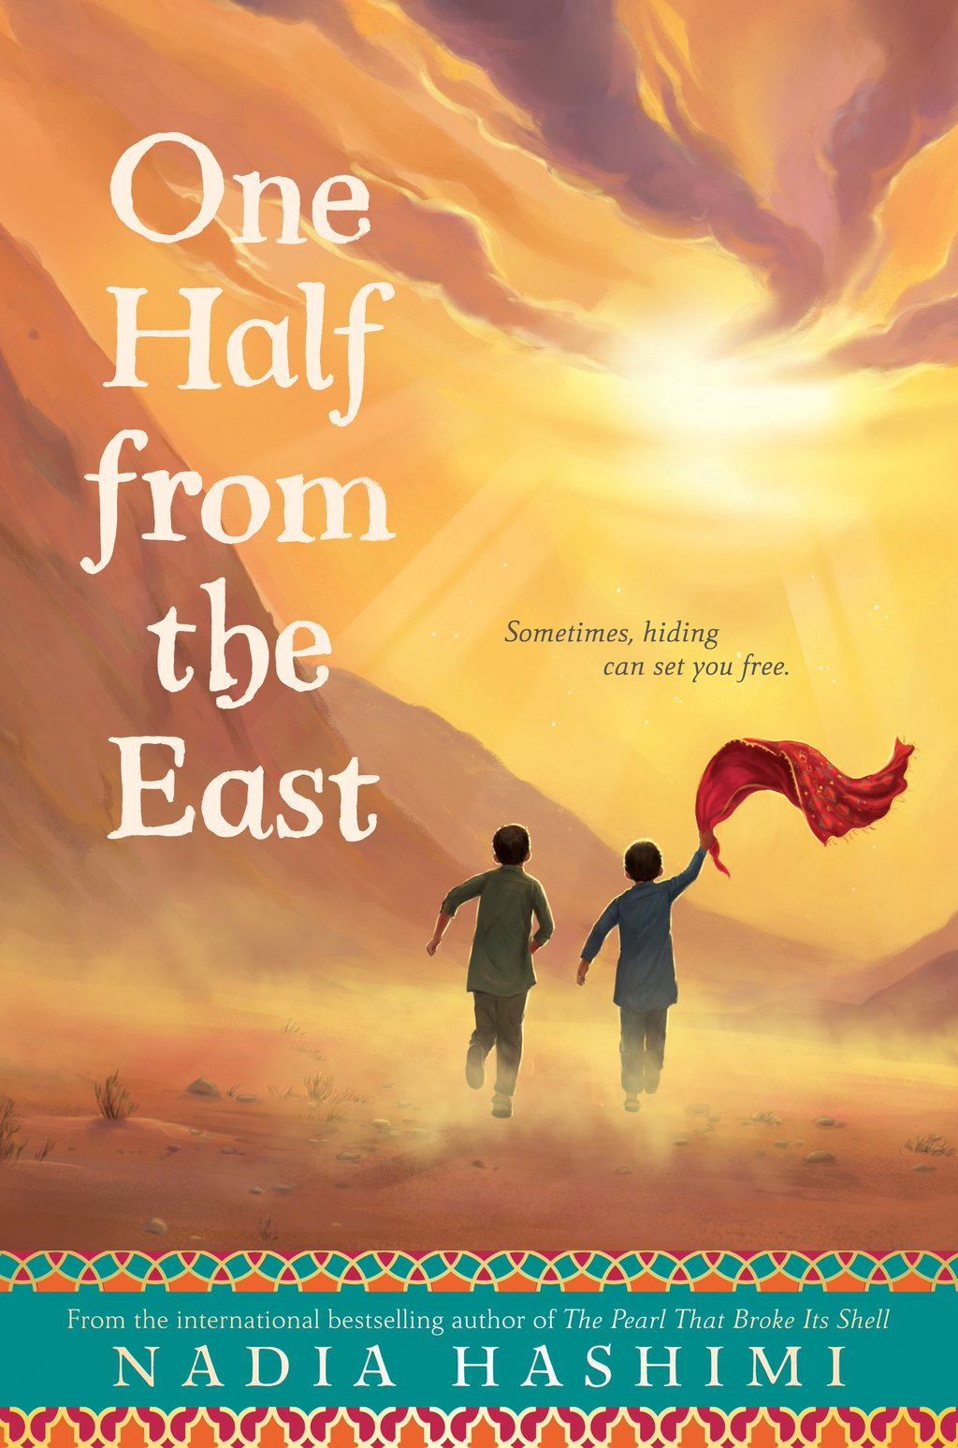
One Half From the East
by Nadia Hashimi

Obayda’s family is in need of some good fortune, and her aunt has an idea to bring the family luck—dress Obayda, the youngest of four sisters, as a boy, a bacha posh.
Life in this in-between place is confusing, but once Obayda meets another bacha posh, everything changes. Their transformation won’t last forever, though—unless the two best friends can figure out a way to make it stick and make their newfound freedoms endure.
Nadia Hashimi’s first novel for adults, The Pearl That Broke Its Shell, was a bestseller that shares a bacha posh character with One Half from the East.
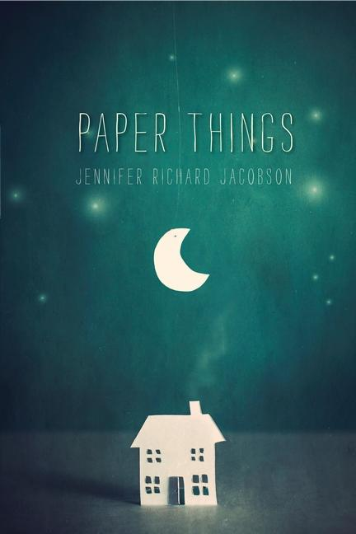
Paper Things
by Jennifer Richard Jacobson

When Ari’s mother died four years ago, she had two final wishes: that Ari and her older brother, Gage, would stay together always, and that Ari would go to Carter, the middle school for gifted students. So when nineteen-year-old Gage decides he can no longer live with their bossy guardian, Janna, Ari knows she has to go with him. But it’s been two months, and Gage still hasn’t found them an apartment. He and Ari have been “couch surfing,” staying with Gage’s friend in a tiny apartment, crashing with Gage’s girlfriend and two roommates, and if necessary, sneaking into a juvenile shelter to escape the cold Maine nights. But all of this jumping around makes it hard for Ari to keep up with her schoolwork, never mind her friendships, and getting into Carter starts to seem impossible. Will Ari be forced to break one of her promises to Mama? Told in an open, authentic voice, this nuanced story of hiding in plain sight may have readers thinking about homelessness in a whole new way.

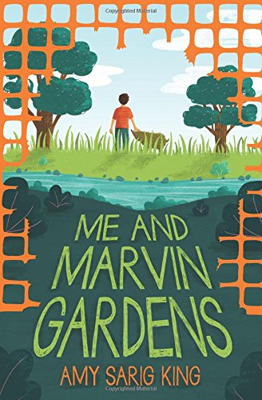
Me and Marvin Gardens
by Amy Sarig King

Obe Devlin has problems. His family's farmland has been taken over by developers. His best friend Tommy has abandoned him. And he keeps getting nosebleeds, because of that thing he doesn't like to talk about. So Obe hangs out at the nearby creek, in the last wild patch left, picking up trash and looking for animal tracks.
One day, he sees a creature that looks kind of like a large dog. And as he watches it, he realizes it eats plastic. Only plastic. Water bottles, shopping bags... No one has seen a creature like this before. The animal--Marvin Gardens--becomes Obe's best friend and biggest secret. But to keep him safe from the developers and Tommy and his friends, Obe must make a decision that might change everything.
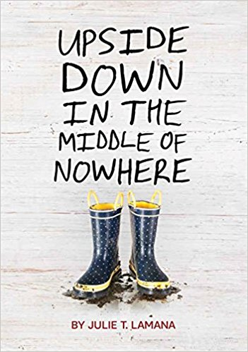
Upside Down in the Middle of Nowhere
by Julie Lamana

Armani Curtis can think about only one thing: her tenth birthday. She's having a party, her mama is making a big cake, and she has a good feeling about a certain wrapped box.

Turning ten years old is a big deal to Armani. It means she's older, wiser, more responsible. But when Hurricane Katrina hits the Lower Nines of New Orleans and tears her world apart, Armani realizes that being ten means being brave, watching loved ones die, and mustering all her strength to help her family weather the storm. A gripping story of courage and survival, Upside Down in the Middle of Nowhere celebrates the power of hope and love in the face of the unthinkable.
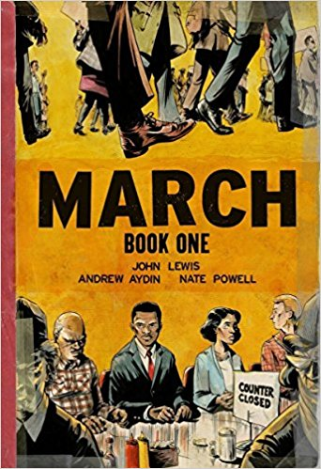
March, Book 1
by John Lewis

Congressman John Lewis is an American icon, one of the key figures of the civil rights movement.
Now, to share his remarkable story with new generations, Lewis presents March, a graphic novel trilogy, in collaboration with co-writer Andrew Aydin and New York Times best-selling artist Nate Powell.
March is a vivid first-hand account of John Lewis' lifelong struggle for civil and human rights, meditating in the modern age on the distance traveled since the days of Jim Crow and segregation. Rooted in Lewis' personal story, it also reflects on the highs and lows of the broader civil rights movement.
Book One spans John Lewis' youth in rural Alabama, his life-changing meeting with Martin Luther King, Jr., the birth of the Nashville Student Movement, and their battle to tear down segregation through nonviolent lunch counter sit-ins, building to a stunning climax on the steps of City Hall.
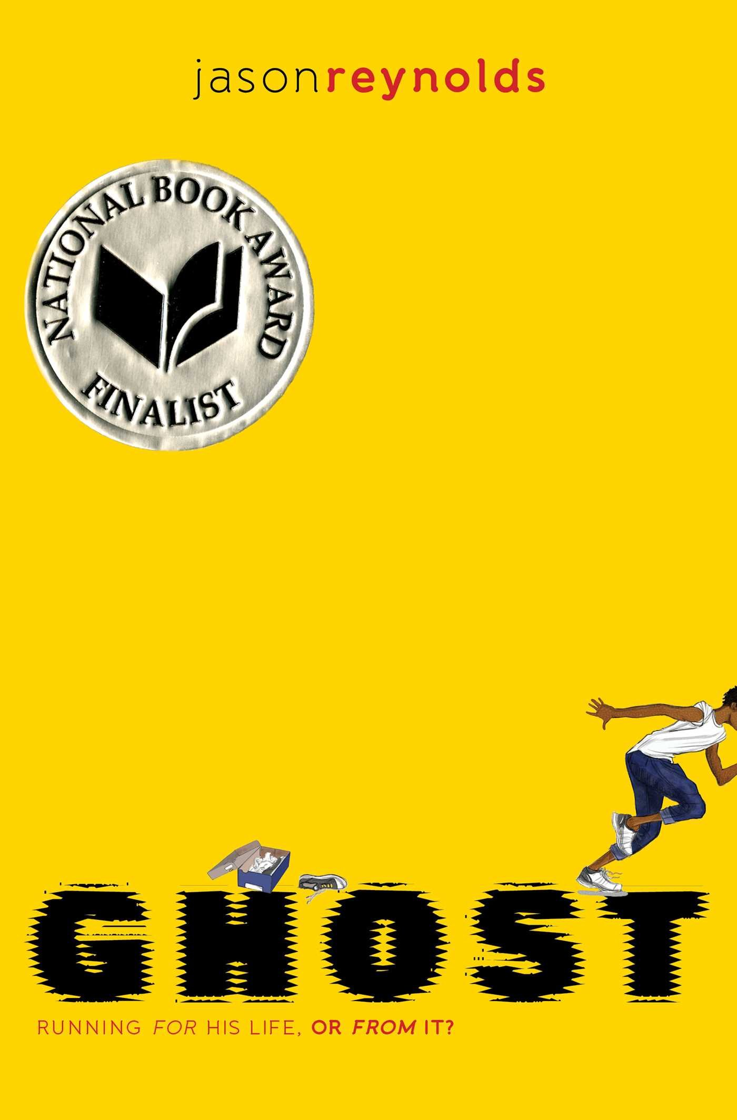
Ghost
by Jason Reynolds

Ghost. Lu. Patina. Sunny. Four kids from different backgrounds, chosen for an elite middle school track team—a team that could qualify them for the Junior Olympics if they can get their acts together. They all have a lot to lose, but they also have a lot to prove.
Running. That’s all Castle “Ghost” Cranshaw has ever known. But Ghost has been running for the wrong reasons—it all started with running away from his father, who, when Ghost was a very little boy, chased him and his mother through their apartment, then down the street, with a loaded gun, aiming to kill. Since then, Ghost has been the one causing problems—and running away from them—until he meets Coach, an ex-Olympic Medalist who sees something in Ghost: crazy natural talent. If Ghost can stay on track, literally and figuratively, he could be the best sprinter in the city. Can Ghost harness his raw talent for speed, or will his past finally catch up to him?

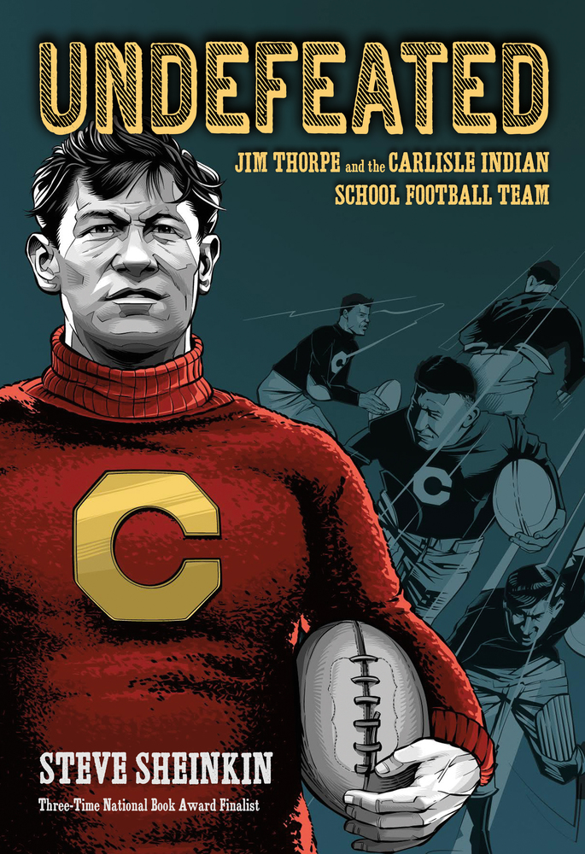
Undefeated
by Steve Sheinkin

Jim Thorpe: Super athlete, Olympic gold medalist, Native American
Pop Warner: Indomitable coach, football mastermind, Ivy League grad
Before these men became legends, they met in 1907 at the Carlisle Indian Industrial School in Pennsylvania, where they forged one of the winningest teams in American football history. Called "the team that invented football," they took on the best opponents of their day, defeating much more privileged schools such as Harvard and the Army in a series of breathtakingly close calls, genius plays, and bone-crushing hard work.
This is an astonishing underdog sports story―and more. It’s an unflinching look at the U.S. government’s violent persecution of Native Americans and the school that was designed to erase Indian cultures.
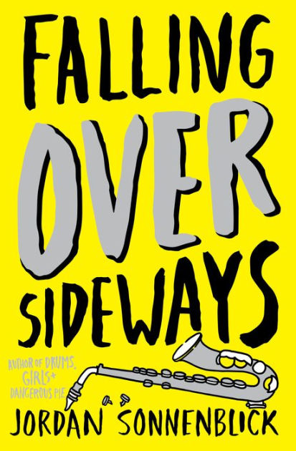
Falling Over Sideways
by Jordan Sonnenblick

Claire's life is a joke . . . but she's not laughing. While her friends seem to be leaping forward, she's dancing in the same place. The mean girls at school are living up to their mean name, and there's a boy, Ryder, who's just as bad, if not worse. And at home, nobody's really listening to her -- if anything, they seem to be more in on the joke than she is.
Then into all of this (not-very-funny-to-Claire) comedy comes something intense and tragic -- while her dad is talking to her at the kitchen table, he falls over with a medical emergency. Suddenly the joke has become very serious -- and the only way Claire, her family, and her friends are going to get through it is if they can find a way to make it funny again.

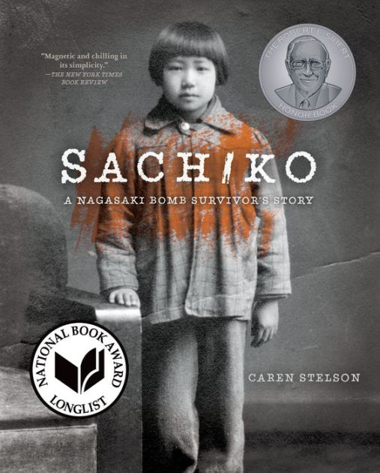
Sachiko: A Nagasaki Bomb Survivor’s Story
by Caren Stelson

This striking work of narrative nonfiction tells the true story of six-year-old Sachiko Yasui's survival of the Nagasaki atomic bomb on August 9, 1945, and the heartbreaking and lifelong aftermath. Having conducted extensive interviews with Sachiko Yasui, Caren Stelson chronicles Sachiko s trauma and loss as well as her long journey to find peace. This book offers readers a remarkable new perspective on the final moments of World War II and their aftermath.
"Filled with powerful archival images, the book also sensitively describes the historical context." – The Washington Post
"Luminous, enduring, utterly necessary." – Booklist

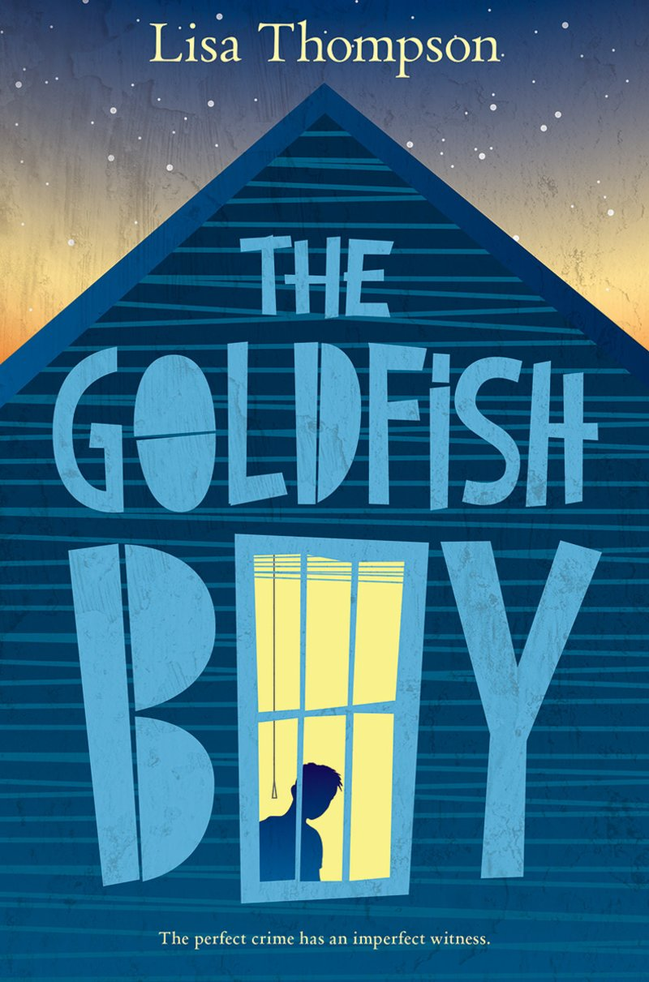
The Goldfish Boy
by Lisa Thompson

Matthew Corbin suffers from severe obsessive-compulsive disorder. He hasn't been to school in weeks. His hands are cracked and bleeding from cleaning. He refuses to leave his bedroom. To pass the time, he observes his neighbors from his bedroom window, making mundane notes about their habits as they bustle about the cul-de-sac.
When a toddler staying next door goes missing, it becomes apparent that Matthew was the last person to see him alive. Suddenly, Matthew finds himself at the center of a high-stakes mystery, and every one of his neighbors is a suspect. Matthew is the key to figuring out what happened and potentially saving a child's life... but is he able to do so if it means exposing his own secrets, and stepping out from the safety of his home?

