WANTED
DEAD or ALIVE!

If you encounter any of these AWOL books, please return them immediately to the library’s custody!
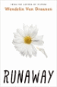
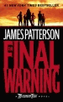
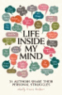

Guinness World Records 2019

Life Inside My Mind
Runaway
by Wendelin Van Draanan
The Final Warning
Alex Rider series, bk 4

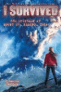
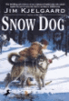
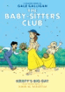
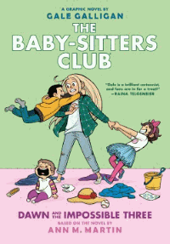

Babysitter’s Club #5
Dawn and the Impossible Three
Snow Dog
by Jim Kjelgaard
I Survived: the
Eruption of Mt. St. Helens
Babysitter’s Club #6
Kristy’s Big Day

