FUN STUFF for 

DID YOU KNOW!...

Feb. 11th is

“Don’t Cry Over Spilled Milk” Day!



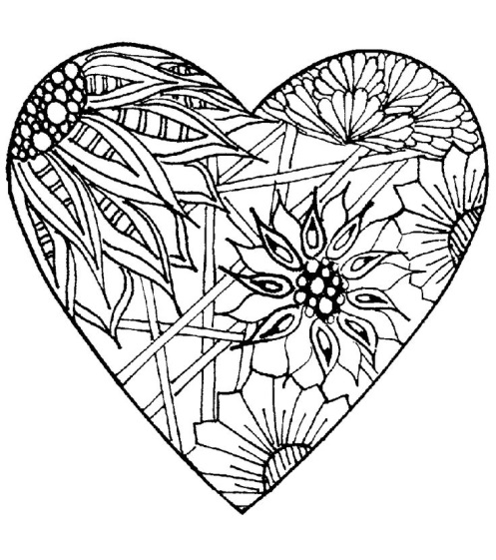

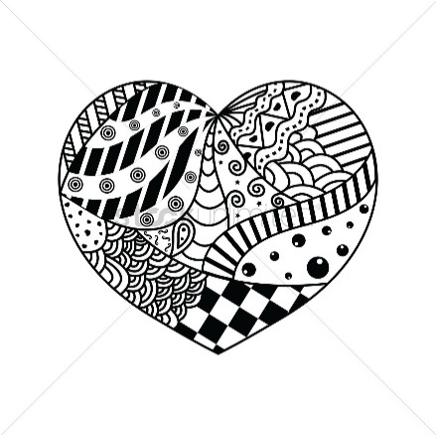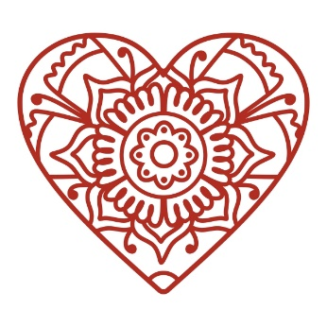

Color Me!



JOKEs:

Q. What did the stamp say to the envelope on Valentine’s Day?

A. I’m stuck on you!

Q. How did the phone propose to his girlfriend?

A. He gave her a ring!

RIDDLE:

How many months have 28 days?

DID YOU KNOW!...

On Feb. 4th Facebook was launched in 2004.

Facebook is the FAVORITE Social Media form, followed closely by YouTube.

JOKE:

Q. What did the farmer give his wife for Valentine’s Day?

A. Hogs and kisses!

­­

ALL of them!



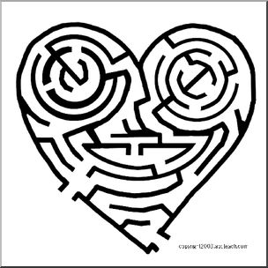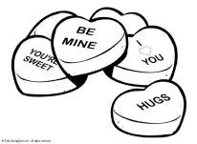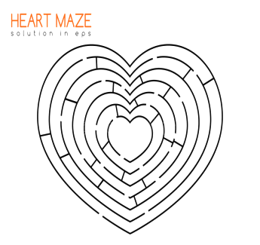

DID YOU KNOW!...

The first modern chocolate bar was made in **1847** when Joseph Fry learned he could make a moldable chocolate paste by adding melted cacao butter back into Dutch cocoa.

By 1868 the Cadbury Company was selling boxes of chocolate candies in England.

DID YOU KNOW!...

People’s FAVORITE candy to buy & give for Valentine’s Day is a heart-shaped box of chocolates.

Envelope

RIDDLE:

What word begins with an E and ends with an E, but only contains 1 letter?