

Mystery

*March*







**IS THIS FLAT … or NOT?**

**MYSTERIOUS SPHERES**

*What are they? Who made them??*

A rock in South Africa is about 2.8 billion years old. Miners there found some mysterious metal spheres in there. They’re about 1 inch in diameter and have three parallel grooves etched around its middle. Some are solid bluish metal with flecks of white while others are hollow & filled with a spongy white substance. The origin and reason of these spheres are unknown.

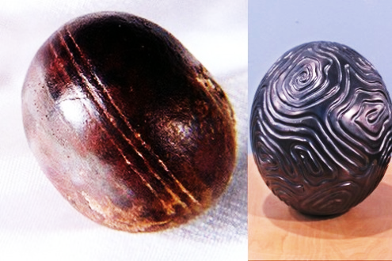



Mystery

*March*







**RED RAIN**

*What IS it? What caused it?*

From July to Sept. 2001 heavy rain fell sporadically in Kerala, Southern India. However, the rain was red. The clouds seemed to spit out blood. Despite much research, it is still unknown what caused the red rain.

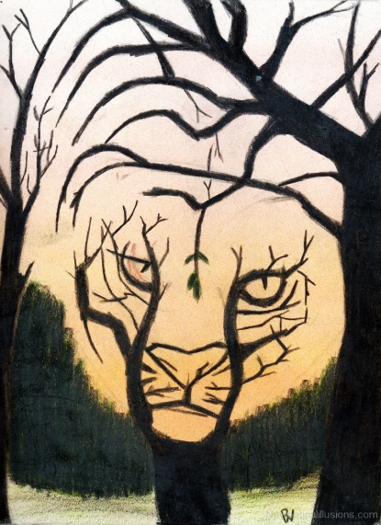





Mystery

*March*



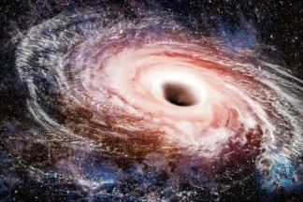

**It’s a Mystery: WHAT’S going on in a black hole?**

[**Black holes**](https://www.nasa.gov/audience/forstudents/k-4/stories/nasa-knows/what-is-a-black-hole-k4.html) are places in space where gravity is so strong that even light can’t escape, so no rocket has ever been able to explore the insides. le to say what happens inside a black hole.

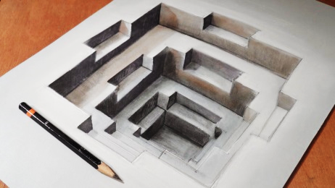

**A HOLE IN WATER??**

This CAN be explained. Do you know how it happens? le to say what happens inside a black hole.

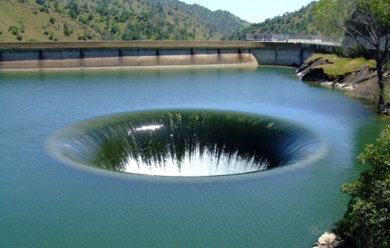



Mystery

*March*



**LOST CITY of ATLANTIS**

**No one yet has found this island that mysteriously disappeared but was believed to have had the most advanced people in the world.**

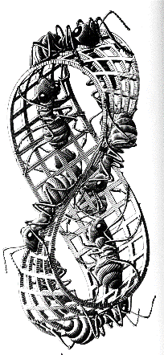





**a MAJOR Mystery:**

***What team*** will be this year’s big winner???

**What’s your guess???**

**STONEHENGE**

Stonehenge dates from 2500–3000 BC, but it’s full purpose and creation still remain one of the greatest mysteries of human history.

