Oregon School District Library Homepage

Parents and students can now access the Oregon School Library at home on the Internet. Your child can log in at destiny.ocusd.net and click on the school they attend.

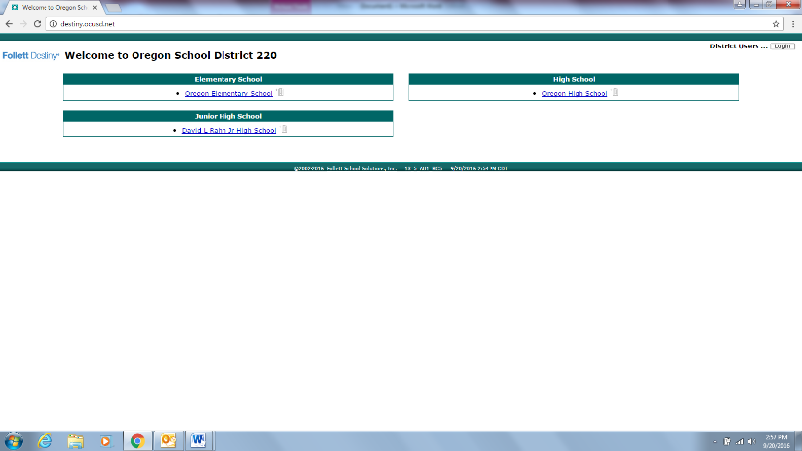

After clicking the name of the school, have the student log in using the same username and password that they use at school. (First four letters of first name, first five of last name.) The password is hawks
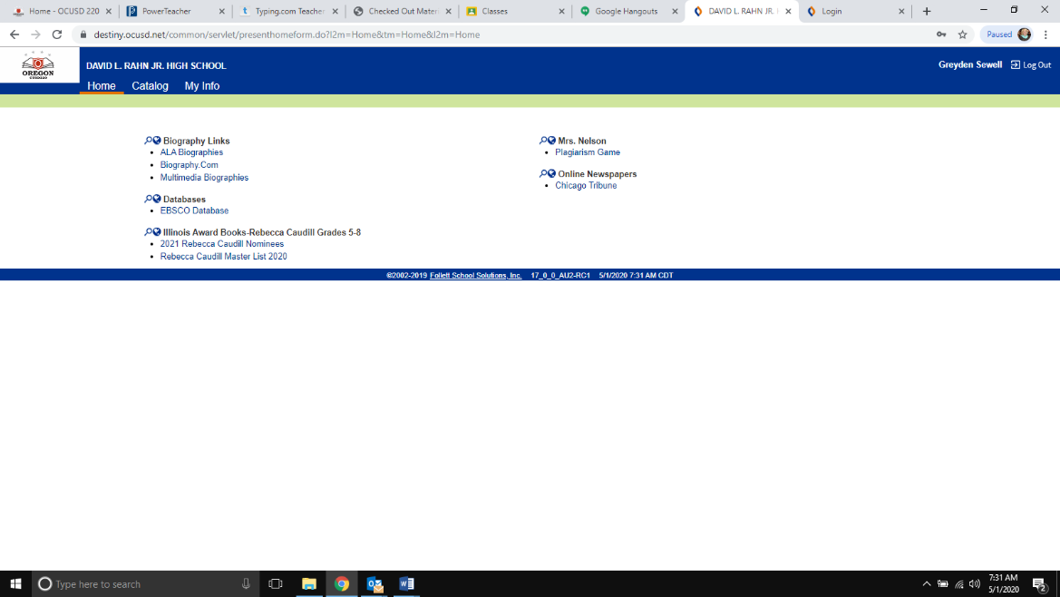
Student name here.
[Grab your reader’s attention with a great quote from the document or use this space to emphasize a key point. To place this text box anywhere on the page, just drag it.]

Click on MY INFO.

Selecting “My Info” from the menu bar will allow you to see what books you have checked out and the due date.

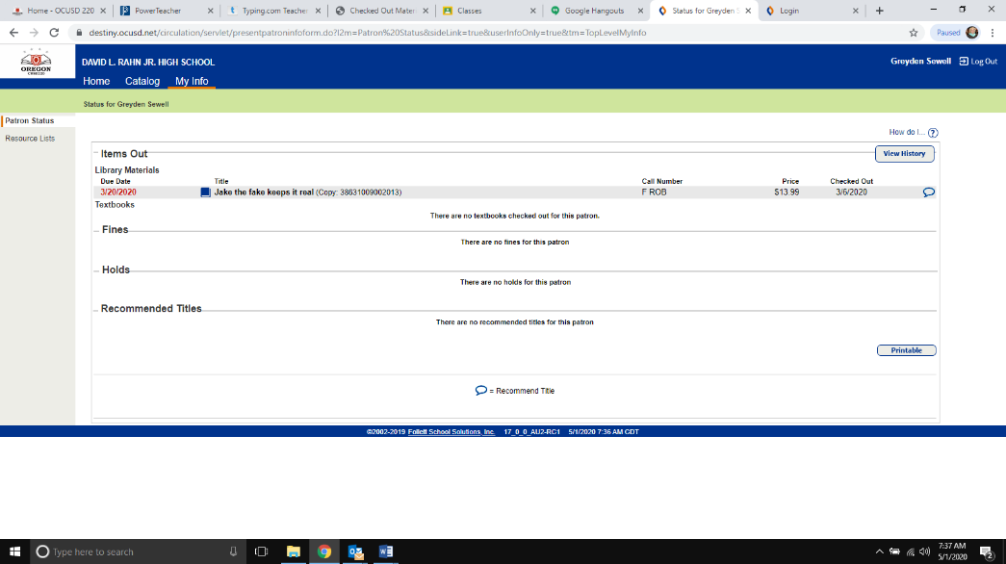
After clicking MY INFO, the next screen
Shows any library books checked out here.

Textbooks would be below this line

If the book is marked in red, it is overdue. Please do not worry about that. Just return any library book or textbook from any building Monday through Friday from 8-3 to OES. Books can also be dropped off during student belonging pick up. Any questions or challenges?
Contact Kathryn Green, District Librarian kgreen@ocusd.net

