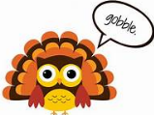
Q: Why do pumpkins sit on people’s porches?
A: They have no hands to knock on the door.
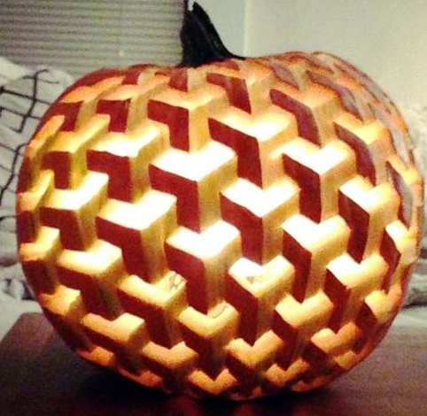
Try to carve this!!!!

Q: Why was Cinderella not very good at softball?
A: Because her coach was a pumpkin.

DID YOU KNOW?
Pumpkins are fruits!

Q: What happened when the turkey got into a fight?
A: He got the stuffing knocked out of him.

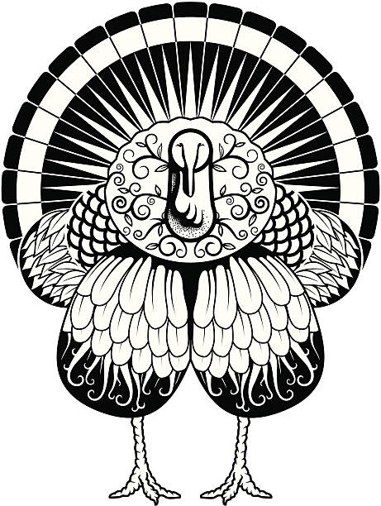
Color this guy!

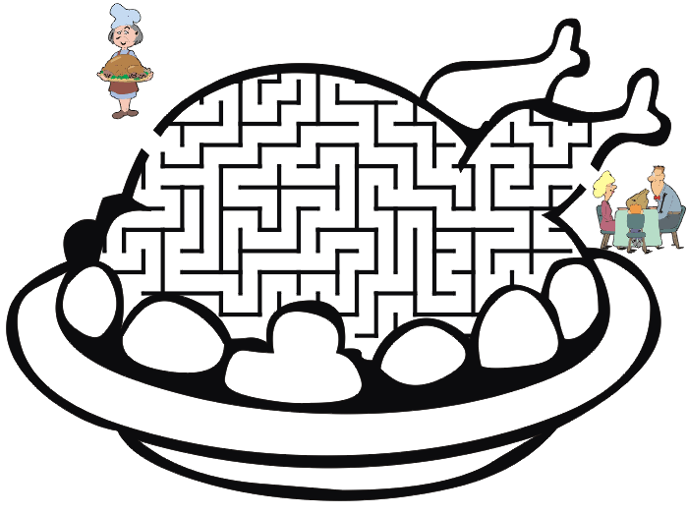
Q: What key won’t open any door?
A: A turkey!

DID YOU KNOW?
Turkeys can run up to 25 mph and fly up to 55 mph.

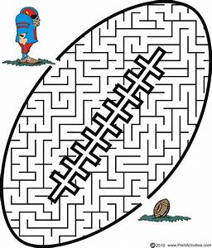

Q: Why did the football coach go to the bank?
A: To get his quarter back.
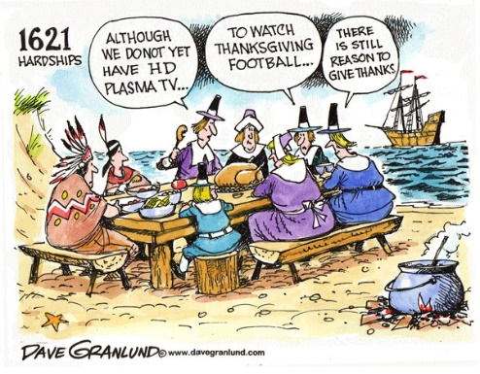

Q: Why didn’t the dog want to play football?
A: It was a boxer.

DID YOU KNOW?
NFL players weren’t required to wear helmets until 1943. Before that, they grew their hair long – thinking it would protect their heads!
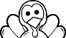

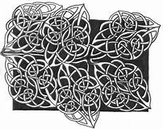
COLOR THESE COOL LEAVES!

Q: What did the tree say to autumn?
A: Leaf me alone!

If money grew on trees, autumn would be the best season ever!

