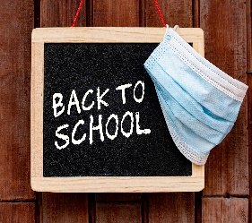

For BMS students





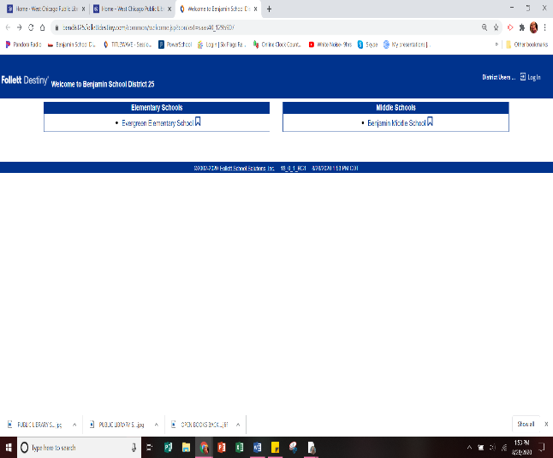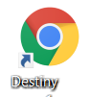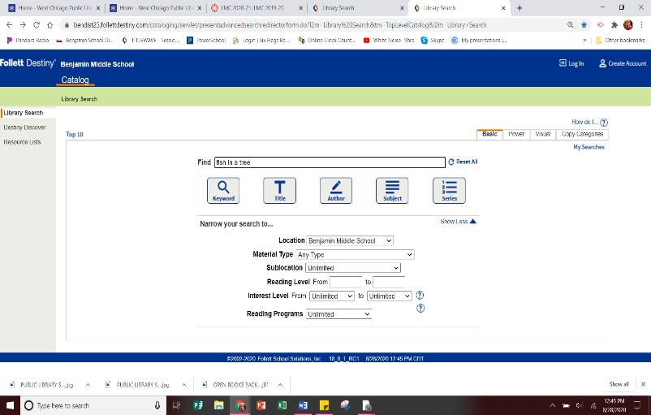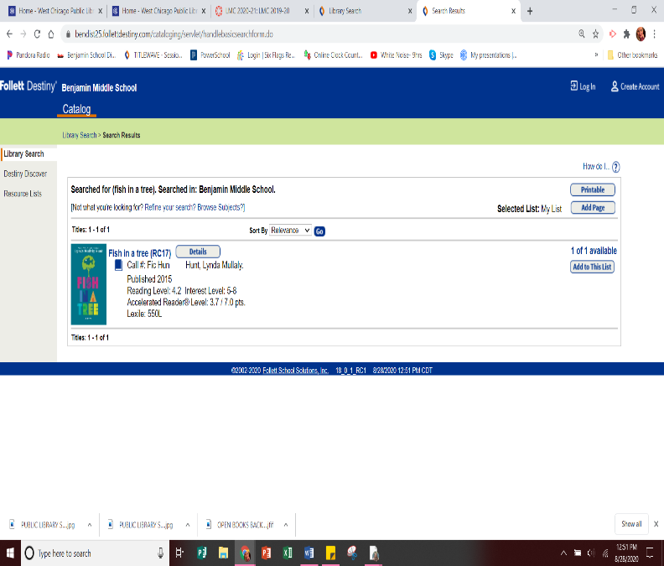

**Directions to Check out a book from Benjamin’s Library:**

1. Login to your device.
2. Click on the Destiny icon
   * Select Benjamin Middle School
3. Search our Library Catalog
   * Example book search: Fish in a Tree
4. Click on the book to see if it is available
   * On school days, Mrs. Hansen will check her email at 11:00am & 2:00pmfor book requests
5. If you would like to request a copy 0f an available book, email Mrs. Hansen at khansen@benjamin25.org
   * Info needed in your email:
     + Book title & author
   * The book will be pulled & ready for

pick-up the next day in the lobby

* + - The lobby is open M-F from 7:00am-3:00pm

**BMS students,**

**Are you wondering how YOU can check a book out that our library owns?**

**READ to find out!**

* + 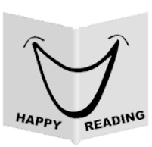

If you have any questions, please call the LMC or email Mrs. Fiorini at mfiorini@benjamin25.org

Mrs. Fiorini & Mrs. Hansen