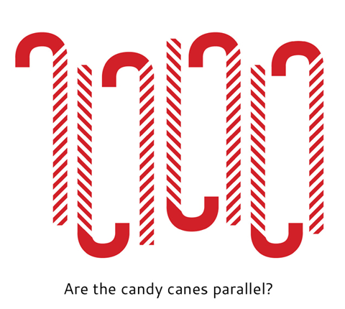

**Are the candy canes parallel?**



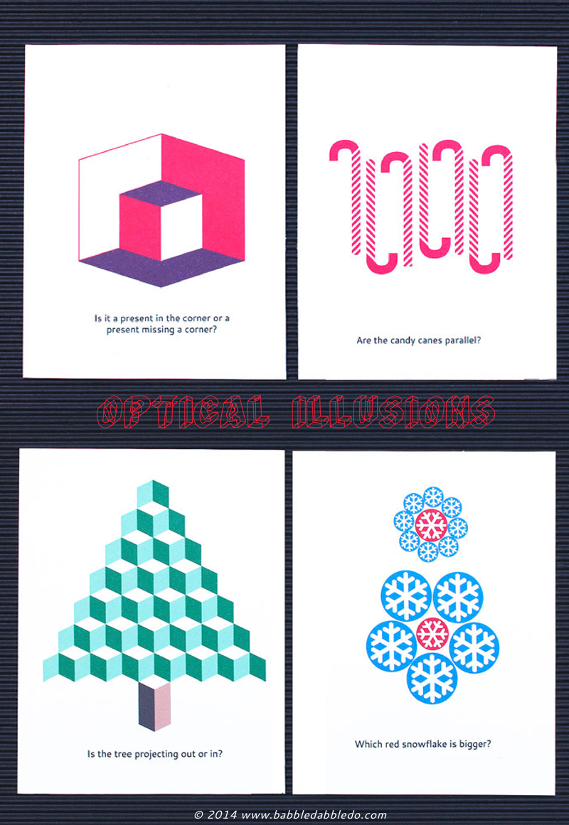

**Is this a gift box in the corner or a box *missing* a corner?**

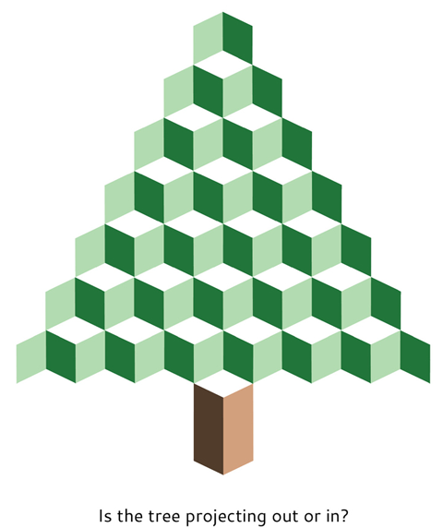

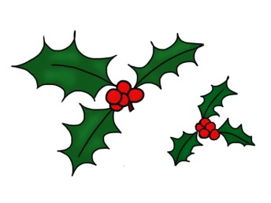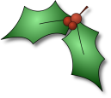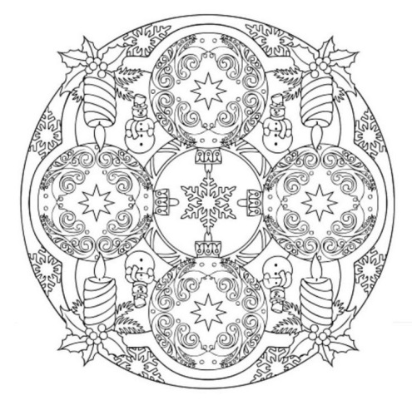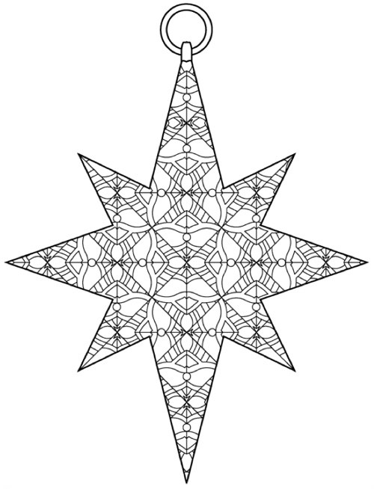

**RIDDLE #1: Where does Christmas come before Thanksgiving?**

Shapes to

color

**RIDDLE #2: What’s so special about the Christmas alphabet?**

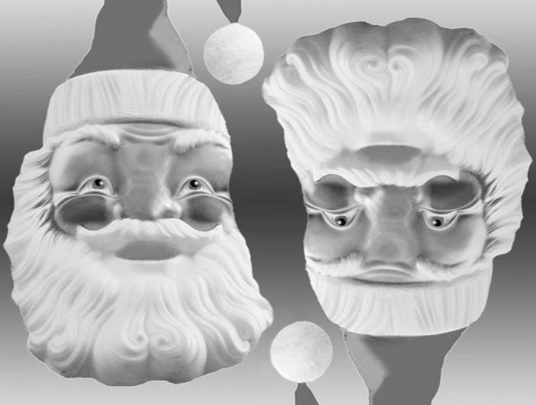

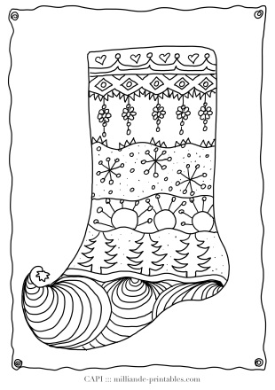

Shapes to color

**RIDDLE:**

What do you get

if you cross an

apple & a

Christmas

tree?

**Is this tree sticking out or sinking in?**

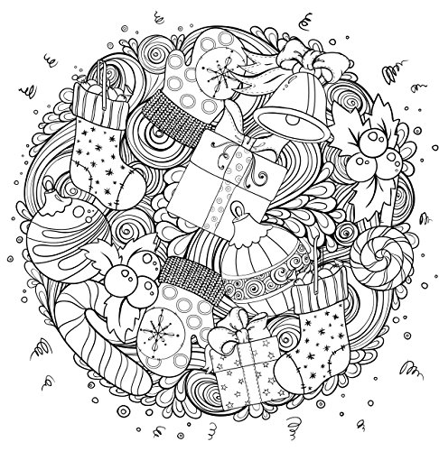

**RIDDLE**: Who’s

never hungry on Christmas?

**ANSWER**: The

turkey, because

he’s always

stuffed!

**Is this Santa or just an old man?**

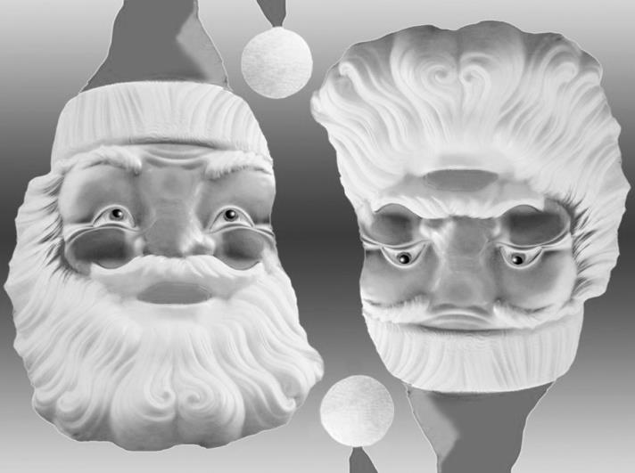

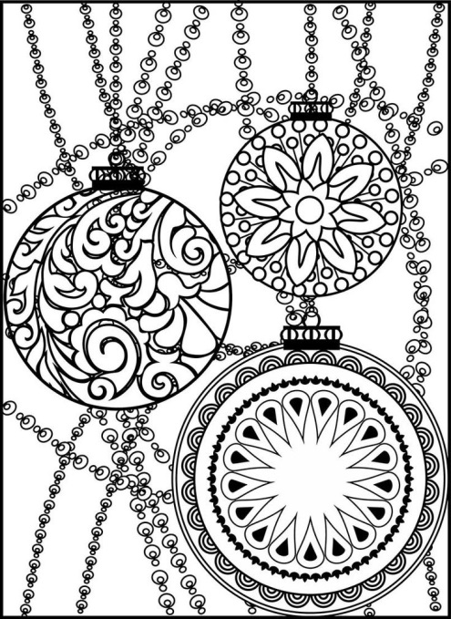

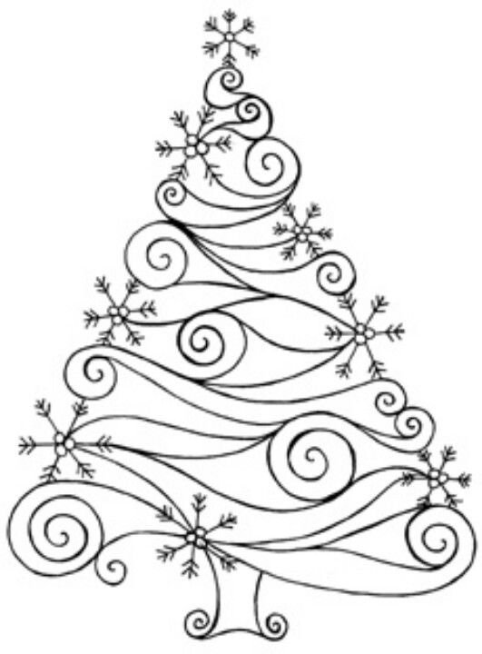

**ANSWER:**

A pine-apple!



**ANSWERS:**

**1.** In the dictionary

**2**. Because there’s NOEL.