

oke’s on

anuary

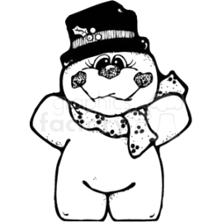

Why did Frosty the Snowman break up with his girl friend?

He thought she was

a flake.



What do you call a snowman dance?

A snowball.



Why don’t mountains get cold in the winter?

They wear snow caps

.

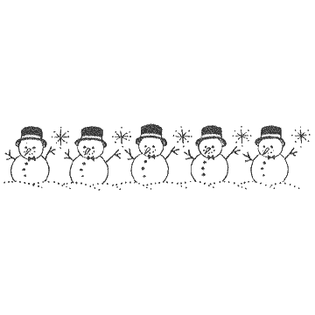



oke’s on

anuary

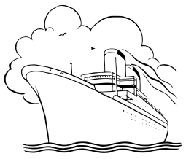

Where can you find an ocean without any water?



On a map.

What vegetable is forbidden on ships?



Leeks.

Why don’t oysters give to charity?

Because they’re shellfish.





oke’s on

anuary



Why did the boy eat his homework?

Because his teacher

said it was a piece of cake.



What do you call a man who can do a year’s worth of homework in two weeks?

Billy Madison.



Why do kids do homework?

Because it doesn’t know how to do itself.



Teachers always tell us to follow our dreams,… ***BUT yet*** they don’t let us sleep in class!





oke’s on

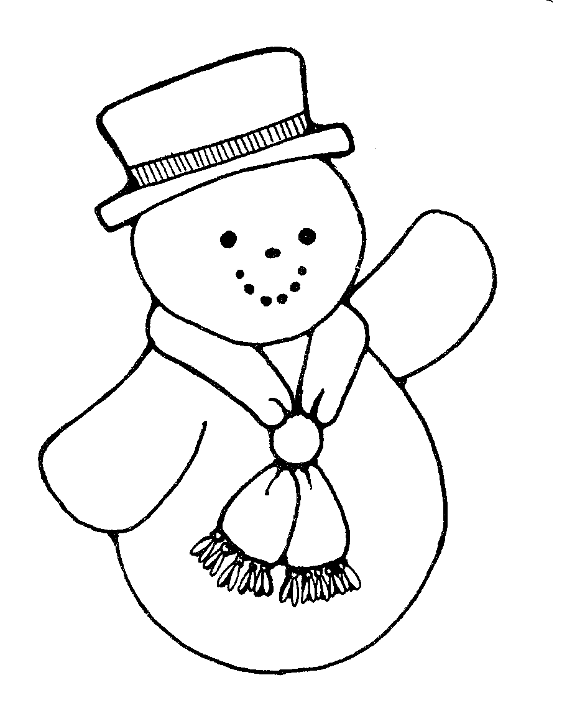anuary

How do snowmen travel around?

By icicle.

.

What does Jack Frost like best about school?

Snow and tell!

What’s a snowman’s favorite Mexican food?

Brrrrr-itos

Where does a snowman keep his money?



In a snow bank.